Break Down Admin
Log-in-All users will log in the same place (users, group leader, master, group leader, judges, clerk of courts, district attorney, admin, super admin)

Q: In existing Database UserType table user type and above mentioned type mismatch. Need to clarify providing screen shot of existing all user type.
My take on the first question about UserType's is as follows:

Since we will probably need to add user types as time goes on, user types need to be completely flexible, and there should be a user interface to add, change, and delete user types. As an example, one LA client wants to have a "Special Agent" user type, and another may want to have a "Notary" user type. Each user type can have a few flags which determines what they can and cannot do, and program functionality (logic) should not be contingent upon a particular user type name, but upon the flags of what they can or cannot do.

Below user type data from existing DB
ID | UserType
1 | Admin
2 | Group Leader
3 | Detective
4 | Judge
5 | Patrol Officer
6 | Master
8 | Guest
9 | Court Administrator
10 | Clerk of Court
11 | Jailor
12 | Account Manager
13 | District Attorney
14 | Records
15 | Commissioner
16 | BWC Administrator
17 | State's Attorney

User-names

- User-name (user name can consist of email address or any 8-character length log-in user name)

Q. User will login with email id or User-Name. Whichever they prefer.
Q. User Name will be 7 or 8 character. 8 characters

- User-name will no longer be their unique identifier, each user will be assigned by the system a unique identifier number.

Q. What is the significance of unique identifier number, whether system will sent this number to user or it’s for only data manipulation for system. The UserID should be assigned by the system. It will be used for data manipulation and can be viewed in the profile of the user. The UserID must be unique so as to allow for the editing of all other user elements (Last Name (for those who marry and/or change their name), First Name (those whom no longer wish to be named Jamarion but like James instead), email, smart phone, department, address, User Name, User Password, etc...).

Password Reset

- Reset password- Eliminate 4-digit code and add a list of 5 unique questions.

- Reset password send link to user email or phone. The user will get another notification that changes have been made.

- An email and text will be sent to Group Leader advising of the user password change.

- Admin and Super Admin will still have the option to reset passwords with one-click.
- user name will no longer be have to be email address, must be 8 characters long.

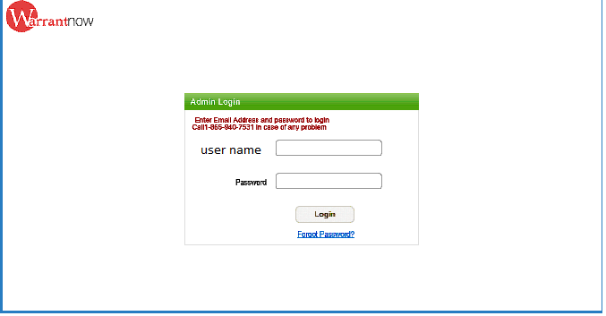
if not same computer 2nd login page

Q. After how many wrong attempt user will redirect to 2nd login page. This will happen any time a person tries to login from a new PC not use in the past. The software needs to keep track of all users new login location. not on # of tries. track the pc they are using to log on (by pc or phone Using MAC.

one of three security questions

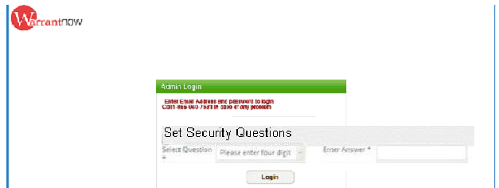

Admin will add, edit, and support all new and present accounts and users. There will be 4 buttons on the Admin home page: (Super Admin will have all options)

- Add or Edit Account
- Users
- Support
- Warrant Search

Q. Admin account will have above four buttons for Super Admin what are other buttons apart from Admin. (As per current system Account Manager is type of Amin users) I am not sure right now but we’ll figure it out.

New accounts/Edit Accounts

Q. Is New/ Edit accounts related to current system Client add /edit functionality. Yes, also need to edit email address

If billing admin box is checked then email will be sent to our billing with above info.

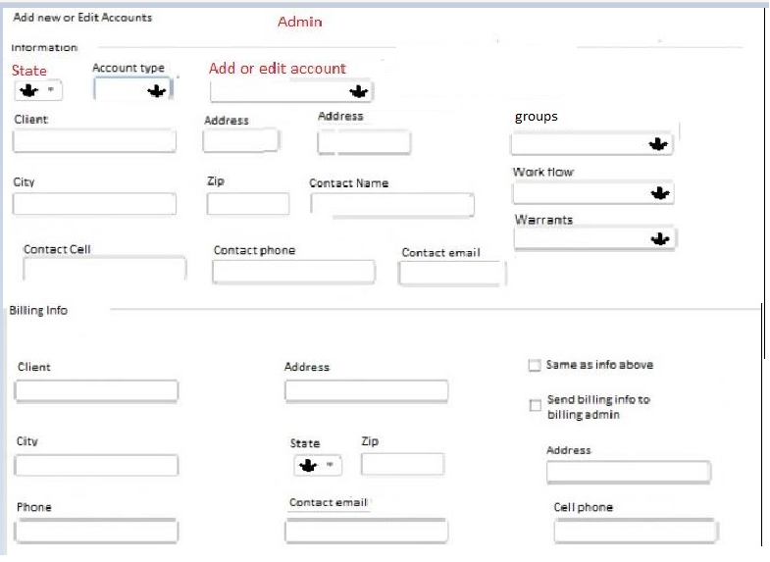

Add- Drop down box of States as the first box. Once a state is picked the edit account box will be filled with accounts form that state. If you want to edit an account, the admin will select the account needed. When an account is chosen all their information will populate in the correct fields so information can be edited as needed. If no account is selected the admin may enter a new account by entering the new information.

Work flow drop down Box
New Accounts Page will feature a drop down box of default work flows. If new account, the admin will select the work flow appropriate for the new account. They may also change work flow here by selecting and saving new work flow.
Below is a list of preselected work flows: Any special work flow will have to be done on the back end.

Work Flow
1. LE to judge
2. LE to reviewer to Judge
3. LE to reviewer to states att to judge
4. LE to states att to reviewer to judge
5. LE to reviewer to LE to states att to LE to Judge
6. LE to states att to LE to reviewer to LE to Judge
2a. Le to reviewer to judge (option to go right to judge)
3a. LE to reviewer to states att to judge (option to go right to judge)
4a. LE to states att to reviewer to judge (option to go right to judge)

Decision tree for Warrant workflow and need to understand meaning of preselected of workflow. I’ve already sent this information to you. We would like to have the above pre populated but would like to edit or make new with a guie like below. This will be drag and drop. For example, the 1st one officer to judge that is a notary. If you wanted to produce this one you would drop the officer in 1st then drag and drop the judge notary next and so on. if we need to add a new option we would just add a new type to top and then drop it in the work flow.

Warrants Drop down
Add- Available Warrants field with a drop down box of default warrants that client has access to. From this point you may also add any additional warrants that have already been produced. Any new warrants that are not in the drop down will be produced and added on the super admin side.

Q. Existing system is it “Warrant Type”. Yes
Groups Drop down
Here will be a list of default groups. There also be a list of additional groups that may be added. Any new groups that are not in the drop down will be added on the super admin side

Account type
Here is a list of default account types to choose from. Any additional new user types will be added on the Super admin side

Users
.
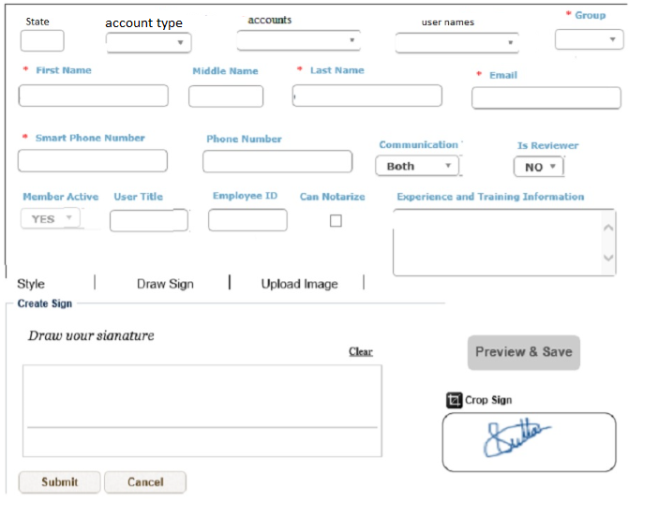

- What will populate on “User Name “ dropdown. If User name dropdown is combination of “First Name” and “Last Name” than same name can be for multiple user which will create problem. If UserName is unique name than we should have text box to input user name in create user screen. The usernames that will populate will be from the specific account you select. Like if you select St. Tammany Parish then those usernames will populate. This is how we will either add a user or edit a user. If we don’t select a username, then we can type in the blank boxes.

Q. Is State drop down or Text box. State dropdown.

Add- Drop down box of States as the first box. Once a state is picked the edit account box will be filled with accounts form that state. Once an account is picked the user box will be filled with users from that account. If you want to edit a user, the admin will select the user needed. When a user is chosen all their information will populate in the correct fields so information can be edited as needed. If no user is selected the admin may enter a new user by entering the new information.
User Types:
- Police Officer/Patrol Officer
- Detective
- Clerk of Court
- Judicial Administrator
- Judge
- Court Administrator
- District Attorney
- States Attorney
Accounts Field will auto-populate with Client names to link new user to, in a drop down box format with information that correlates to the user type selected.

Groups
Once account info is filled out you can choose a group from drop down box to link the new user to. There will be a default set of groups for every account. Admin may assign user to any group in the drown down box. Any groups that need to be added will be done by the Super Admin.
New Users will default to Activated status. The user will not activate until all important information is filled out and signature is uploaded but allow it to save the information entered.

Add Watermark to all signatures.
Q. What we need to print on signature like warrant logo etc. Yes

Admin Support

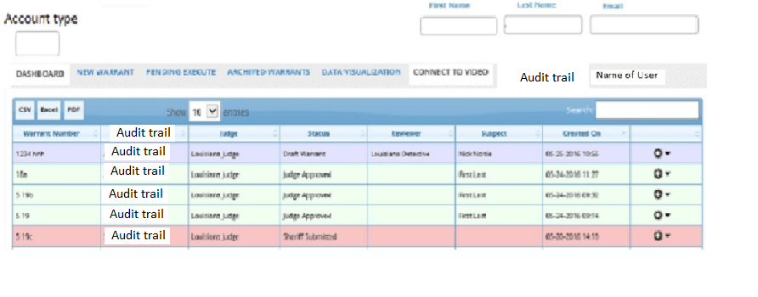
Q. Is audit trail button is visible for both Amin /Super user or other users also (detective, reviewer) It will be visible to all users.

On the right side notice the name of the user appears.

Add- Admin Support Page. We (Admins & Super Admins) need to be allowed to see the user’s dashboard for support calls. We may want this page as view only; no buttons will be click-able except the top tabs. All the dashboard buttons will work but will be read only.

Warrant Search

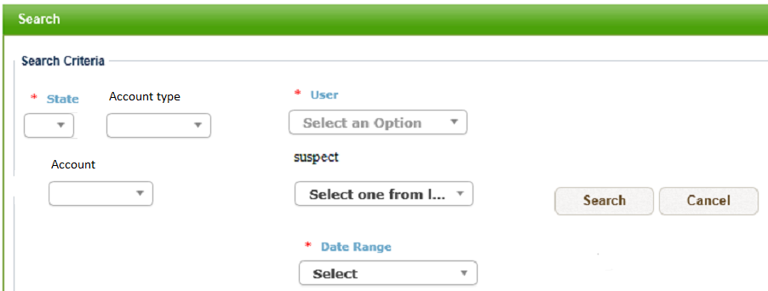

Only have 4 subject fields in Warrant Search:
- State
- User Type (Judge or Agency)
- User Name
- Date Range

When State and User Type is selected then the clients will populate in a drop down box format. Then User will populate a list from that client in a drop down box.

Once a warrant has been found an option to view warrants or email warrants (Encrypted)

Warrant search-able by: User, Suspect Name, Date Range. The only search-able warrants are archived warrants.
We cannot search current warrants that exist on a user’s dashboard.

- When one warrant will be archived After the warrant has been printed or when they hit the A (Archive button)

Super Admin will have all the above + below permissions.

Reports
This is a rough list of reports; we'll need to refine later.

Add Report- Number of Active Users per Client

Reports are deleted or added to each account and an overall report for us. What other reports do we need for future sale, we need maps this is in the system but does not work.
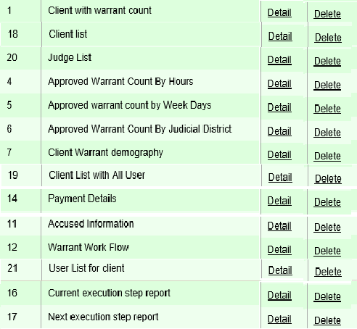

SUPER ADMINISTRATOR

Super Admin will receive the same dashboard as Admin. With a few additional permissions.
- Group drop down will include an option to add new.
- Work flow drop down will include an option to add new.
- Warrant drop down will include an option to add new,
- User type drop down will option to add Admin
- State drop down with option to add new (New state will not appear until all prudent information has been added.) Including counties, districts, warrants, etc. When add new state option is selected a new window will open asking for information required to open this state.

- Please mention all required filed to create a state. What is Warrant here, respective to current system what information we need to show in warrant dropdown? It will be the same process as we do now.

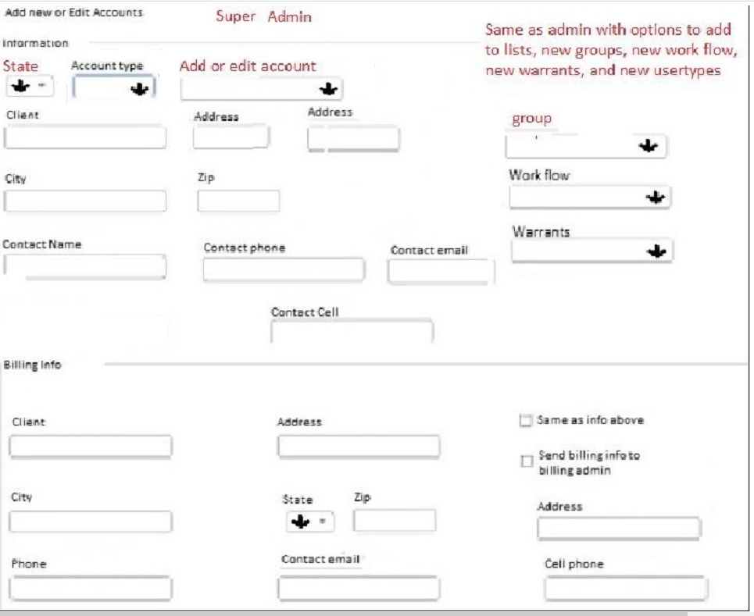

Add- Manage templates (Label it Available Warrants on user’s page) and Manage Work Flow Buttons on New Accounts Page. Only Super Admin’s can edit or change templates and work flow.
- Add change templates and ui's
- Edit templates
- Edit UI's

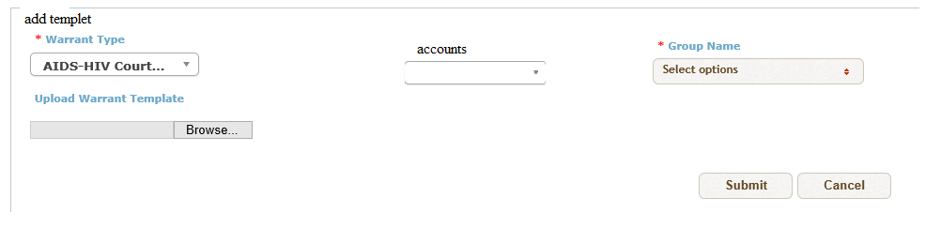

Error Messages
This is where you would get a report of all errors, application errors and system errors.
Q. Number of Menu and Submenu will be change or it will be remain same as existing application.
Q. All listing page UI (e.g. User listing, client listing) will be same or need any changes.

Once we upload their existing form we would like to have a tool box to edit and drag/drop information (bookmarks and placeholders) into certain sections of the document instead of typing them in.

